

BAE Systems Combat Missions Systems
Platforms & Services

Quality Notification
Reminder of GIDEP / Non-conformance notification
May 15th, 2024
To our Valued Suppliers:
This notification is a reminder that you are required to notify BAE Systems, Inc in the event you are providing or have provided non-conforming product subject to a GIDEP non-conformance notification. Notification of non-conformance (s) is stipulated through BAE SQAM (Supplier Quality Assurance Manual) and incorporated in your PO and through Terms and Conditions USGOVA.
- Suppliers are required to monitor and or participate in GIDEP, access can be found at: https://gidep.org/home
- Please be aware of latest TE GIDEP E1R-P-24-01 ref below.
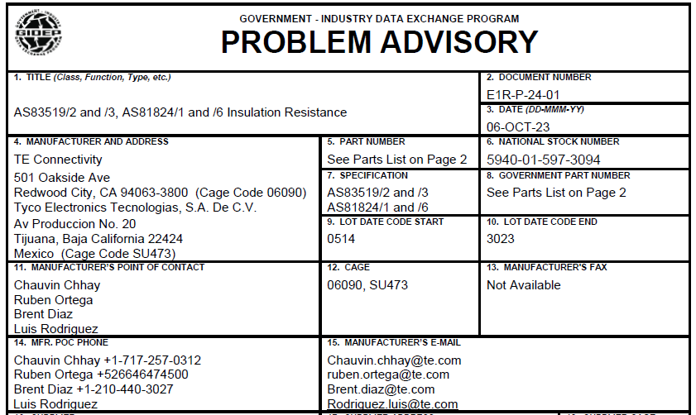

Questions can be directed to your BAE Systems Authorized Purchasing Representative or Supplier Quality Assurance Representative.
Thank you for your continued support!
Supplier Quality Assurance Team
BAE Systems Combat Mission Systems

